**PHOTOS REQUIRED FOR ALL EXAM TAKER’S**

Task Number: -02

**LUCKNOW BRANCH**

All photos must include the date and time

**A photo of the exam taker with ID/passport confirming his/her identity and exam reservation**

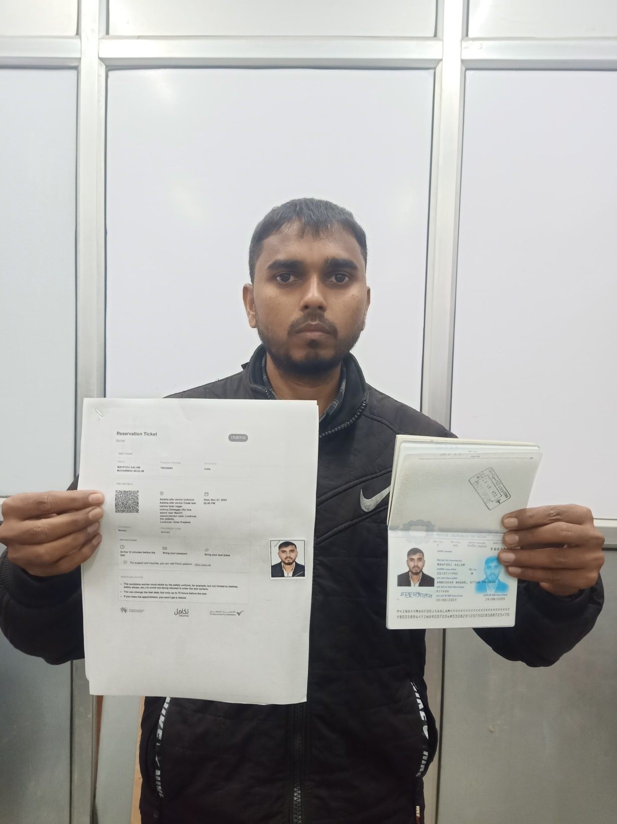

**A photo of the exam taker during conducting the theory test (the test taker & screen shown)**

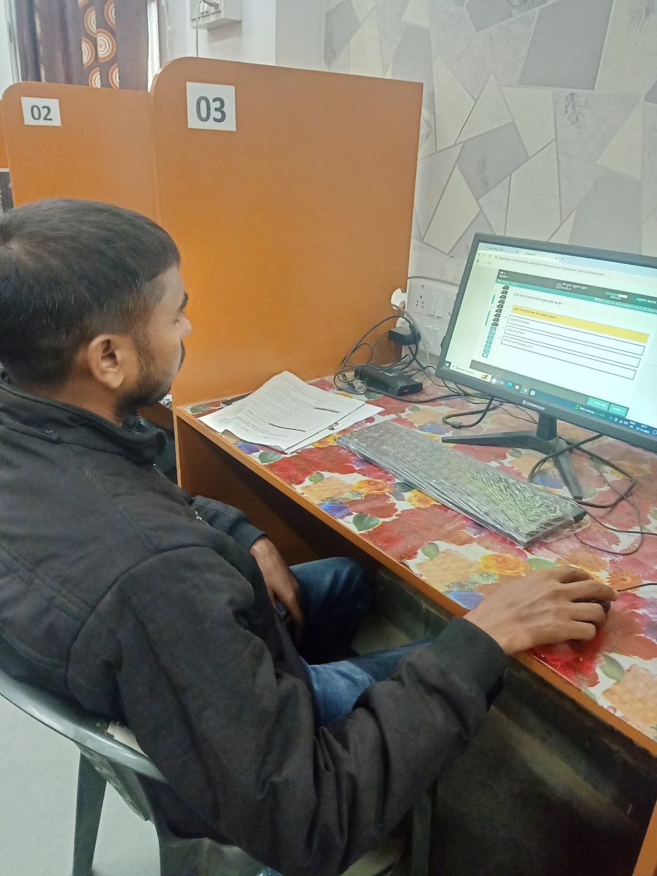

**A photo of the exam taker during conducting the practical test**

